Software Requirements Specification (SRS)
Document Title | UDST Smart Parking Management System SRS
Project Name | UDST Smart Parking Management System
Version | 2.0
Author(s) | Group 4  Malak Alyazji  Lamis Alkahlout,  Sally Jumah  Nour Abounahia
Reviewer(s) | Dr. Ilyes Jenhani
Approver(s) | Dr. Ilyes Jenhani
Creation Date | 2025-02-08
Last Update | 2025-02-19
Status | Under Review
Document Reference | SRS-Group4-Parking
Scope | This SRS covers the software requirements for a digital parking reservation, management, and notification system for UDST campus.

1. Introduction

1.1 Purpose
This Software Requirements Specification (SRS) documents the functional and non-functional requirements for the UDST Smart Parking Management System. The system aims to improve parking availability, reduce search time, and enhance user experience on campus. The intended audience includes:
- System Analysts and Developers responsible for designing and implementing the system.
- QA/Test Engineers for validating the system against these requirements.
- Stakeholders/Project Managers overseeing development and ensuring alignment with business objectives.
1.2 Document Conventions
This document follows the MoSCoW model to categorize requirements by priority:
• Must (Shall) indicates a mandatory requirement.
• Should indicate a requirement that is recommended (but may have valid exceptions).
• May or Optional indicates a feature that is not mandatory.
1.3 Intended Audience and Reading Suggestions
- Developers: Focus on Sections 3 and 5
- Testers: Use Section 3 for test case development
- Project Managers: Review entire document for scope and alignment

1.4 Scope
- In Scope: Online reservations, availability display, notifications, feedback system, event parking, automatic release
- Out of Scope: Payment processing, hardware installation, advanced surveillance

1.5 References
- ISO/IEC/IEEE 29148:2018 – Requirements engineering standard
- UDST Parking Policy Document
- Similar smart parking system case studies (e.g., SmartPark, ParkMobile)

2. Overall Description

2.1 Product Perspective
The parking booking website is a web-based system designed to support parking reservations and management within a university campus.
This system:
- Allows students/staff to book and cancel parking reservations.
- Provides real time visibility of available parking spaces across campus parking zones.
- Supports different user roles, including students, staff, and administrators.
- Assists campus parking administrators in monitoring parking usage and managing reservations.

2.2 Product Functions
- User Authentication Users authenticate using university SSO credentials.
- Parking Reservation: Users make reservations in their preferred parking spaces based on date and time.
- Booking View/Cancellation: Users can view and cancel their bookings.
- Notifications: The system sends booking confirmations and reminders before start/end of the booking.
- Feedback: Users can submit feedback, reports, and complaints.
- Booking Management: System provides administrative access to monitor parking usage and manage further reservations.

2.3 User Classes and Characteristics
- Students and staff:
- Primary users of the system.
- Require basic technical skills to create, modify, cancel reservations, and submit feedback.
- Must log in using university credentials.
- Access the system via web interface.
- Parking administrators:
- Manage parking policies, time slot configurations, and space availability.
- Monitor all reservations (students, staff, and guests).
- Generate reports and enforce parking rules.
- Require administrative access and basic system training.

2.4 Operating Environment
- The system operates as a web-based application.
- Accessible through web browsers on desktop and mobile.
- The system integrates with the university authentication system for user verification.

2.5 Design and Implementation Constraints
- Security Constraints: User data and booking info must be protected and accessible only to authorized users.
- Performance Constraints: Parking availability and booking updates must occur with minimal delay.
- Reliability Constraints: The system must support multiple users without reservation conflicts or delays.

2.6 User Documentation
- On-screen guidance and instructions for parking reservations.
- Notification messages for booking confirmation and reminders.
- Help or FAQ section for further explanation/questions.

2.7 Assumptions and Dependencies
- Users have access to the internet and compatible devices.
- Users comply with parking booking policies and rules.
- All parking spaces included in the system are clearly numbered on-site to correspond with their digital identifiers.
- System reliability depends on the availability of campus IT infrastructure and network services.
- Parking availability is determined based on reservation records only, not physical sensor detection
- Parking access is controlled by security personnel who verify reservation confirmation before allowing entry

- System Features (Functional Requirements)

FR1 | The system shall allow users to log in using valid credentials
FR2 | The system shall display available parking spaces in real time  based on reservation records (not physical sensors).
FR3 | The system shall allow users to reserve a parking space for a specific time slot
FR4 | The system shall record reservation check-in and check-out times.
FR5 | The system shall automatically release unclaimed or expired parking reservations within 15 minutes.
FR6 | The system shall send users a reminder notification 30 minutes before reservation start time, and availability alerts when spaces open.
FR7 | The system shall allow users (students/ staff) to cancel existing parking reservations
FR8 | The system shall allow users to filter available parking spaces based on date/ time / location
FR9 | The system shall allow users to submit feedback (reports and complaints).
FR10 | The system shall allow administrators to reserve parking spaces for guests during events
FR11 | The system shall allow administrators to monitor parking usage and manage (Cancel/Modify) reservations
FR12 | The system shall temporarily lock a selected parking space for 5 minutes while the user completes the reservation process.
FR13 | The system shall pause automatic release when a reservation is being modified until modification is completed.
FR14 | The system shall prevent users from reserving overlapping parking time slots
FR15 | The system shall assign role-based permissions to users (Student / Staff / Administrator)
FR16 | The system shall generate a unique reservation ID upon successful reservation.
FR17 | The system shall display reservation confirmation details including parking number, date, time, and reservation ID
FR18 | The system shall allow users to view their active reservation details for verification purposes
FR19 | The system shall provide administrators with a dashboard displaying key metrics
FR20 | The system shall allow administrators to export reports in PDF format.

3.1 Use Case: View Available Parking Spaces
3.1.1 Description
Allows users to view available parking spaces for a selected date and time
3.1.2 Trigger
User selects “View Parking Availability”
3.1.3 Preconditions
- User is authenticated
- Parking spaces are defined in the system
3.1.4 Main Flow
- User selects the date and time slot.
- System checks reservation records
- System displays a list of available parking spaces in real time.
- System displays updated availability based on current reservation records
- The user may optionally apply filters to refine the displayed parking spaces

3.1.5 Alternative Flows
AF1 – No Parking Available
Condition:
No spaces available for selected time
Flow:
- System displays “No Available Parking” message
3.1.6 Postconditions
- Availability information is displayed to the user
3.1.7 Special Requirements
- Availability shall reflect real-time reservation data.
- Availability shall be based on system records.

3.2 Use Case: Reserve Parking Space

3.2.1 Description
Allows a user to reserve a parking space for a selected time slot.
3.2.2 Trigger
User selects “Reserve Parking”.
3.2.3 Preconditions
- User is authenticated.
- Selected time slot is within allowed duration based on user role.
3.2.4 Main Flow
- User selects a specific parking space from the map.
- System temporarily locks the selected space for 5 minutes.
- System displays a reservation form with space details, date, and time.
- User enters any additional required information (if any).
- User confirms the reservation.
- System verifies the space is still available (not booked by someone else during the 5 minutes).
- System generates a unique Reservation ID.
- System stores the reservation and marks the space as “Reserved.”
- System releases the temporary lock.
- System displays confirmation message with:
  - Parking number
  - Date
  - Time
  - Reservation ID
3.2.5 Alternative Flows
- Space Already Taken During Lock (AF1):
o Another user books the space in the few seconds before confirmation.
o System detects the space is no longer available.
o Displays message: “Sorry, this space was just taken. Please select another.”
o Releases the temporary lock.
o User returns to space selection.
- User Does Not Confirm Within 5 Minutes (AF2):
o User takes longer than 5 minutes to complete the reservation.
o System automatically releases the lock after 5 minutes.
o Space becomes available to other users.
o If the user tries to confirm after lock expires, displays: “Reservation time expired. Please start over.”
- User Cancels During Booking (AF3):
o User selects “Cancel” during the reservation process.
o System immediately releases the temporary lock.
o Space becomes available to other users.
o User returns to main menu.
- Database Error (AF4):
o System cannot save the reservation due to a database error.
o Displays message: “Unable to complete reservation. Please try again.”
o Releases the temporary lock.
o User returns to main menu.
- AF5 – User Modifies During Lock
o User modifies the reservation details (e.g., changes time or parking space) during the 5-minute lock period.
o System detects the modification.
o The 5-minute lock timer resets to give the user more time to complete the reservation.
o User continues with the reservation process

3.2.6 Postconditions
- Successful Reservation: Space is marked as “Reserved” for the specified time. User receives confirmation with Reservation ID.
- Failed/Cancelled Reservation: Space is available again. No reservation record is created.

3.2.7 Special Requirements
- Temporary Lock Duration: The system shall lock a space for exactly 5 minutes while the user completes the reservation.
- Lock Visibility: Other users shall see the locked space as grey and cannot select it.
- Automatic Release: The system shall automatically release the lock after 5 minutes if no confirmation is received.
- Unique ID: Each successful reservation shall have a unique Reservation ID for tracking and verification.

3.3 Use Case: Check-In to Parking
3.3.1 Description
Allows user to check in upon arrival to reserved parking space.
3.3.2 Trigger
User selects “Check-In”.
3.3.3 Preconditions
User has a valid reservation within the allowed check-in time window
3.3.4 Main Flow
- User selects check-in option.
- System verifies reservation and time window.
- System records check-in time.
- System updates reservation status to “Active”.

3.3.5 Alternative Flows

AF1 – Late Check-In
Condition: The user attempts to check in after the allowed grace period.
Flow:
- The system verifies the reservation time window.
- The system detects that the grace period has expired.
- The system updates the reservation status to “Expired”.
- The system updates the parking space status to “Available”.
- The system displays a “Reservation Expired” message.
AF2 – No Active Reservation
- System displays “No Active Reservation” message.
3.3.6 Postconditions
- Check-in time is stored.
- Reservation status updated.
3.3.7 Special Requirements
- Grace Period: Users have 15 minutes after the reservation start
- time to check in. If check-in is not performed within this period,
- the reservation is marked as "Expired" and the space becomes available.
3.4 Use Case: Check-Out from Parking

3.4.1 Description
Allows user to check out when leaving the parking space.
3.4.2 Trigger
User selects “Check-Out.”
3.4.3 Preconditions
– User has active checked-in reservation.
3.4.4 Main Flow
- User selects “check-out”.
- System records check-out time.
- The system calculates parking duration.
- System updates reservation status to “Completed”.
- The system updates the parking space status to “Available”.
- The system prompts the user with an option to submit feedback regarding their parking experience

3.4.5 Alternative Flow
AF1 – Check-Out Not Performed
Condition: User leaves without checking out.
Flow:
- The system detects that the allowed check-out time window has passed.
- The system automatically records the check-out time.
- The system updates the reservation status to “Completed”.
- The system updates the parking space status to “Available”.
3.4.6 Postconditions
– Check-Out time stored.
– Parking space is available.

3.5 Use Case: Submit Feedback, Reports & Complaints
3.5.1 Description
This feature allows users to submit feedback, reports, and complaints related to parking services and issues.
3.5.2 Trigger
The user selects the feedback or complaints option from the system interface.
3.5.3 Preconditions
- The user is registered in the system.
- The system is operational.
3.5.4 Main Flow
- The user selects the “Feedback & Complaints” option.
- The system displays the feedback submission form.
- The user selects a feedback category (e.g., feedback, report, or complaint).
- The user enters feedback, reports, or complaint details.
- The user submits the form.
- The system validates and stores the submission.
- The system displays a confirmation message.
3.5.5 Alternative Flows
AF1 – Incomplete Submission
Condition:
The user submits the form without completing required fields.
Flow:
- The system detects the required information missing.
- The system displays an “Incomplete Form” message.
- The system prompts the user to complete the required fields.

AF2 – System Unavailable
Condition:
The system is temporarily unavailable due to a technical issue.
Flow:
- The user attempts to submit feedback.
- The system fails to process the submission.
- The system displays a “Submission Failed” message.
- The user is prompted to try again later.
3.5.6 Postconditions
- The feedback, report, or complaint is stored in the system.
- The submission is available for administrator review.
3.5.7 Special Requirements
• Submissions shall be timestamped and linked to the submitting user.

3.6 Use Case: Reserve Parking for Guests
3.6.1 Description
This feature allows administration users to reserve parking spaces for guests during events or scheduled visits.

3.6.2 Trigger
The administration user selects the guest parking reservation option.
3.6.3 Preconditions
- The user is authenticated as an administration user.
- Guest parking spaces are available in the system.
3.6.4 Main Flow
- The administration user selects the “Reserve Guest Parking” option.
- The system displays the guest parking reservation form.
- The administration user selects the reservation date and time slot.
- The administration user submits the reservation request.
- The system verifies the availability of guest parking spaces.
- The system confirms the reservation.
- The system updates the guest parking space status to “Reserved”.
3.6.5 Alternative Flows
AF1 – No Guest Parking Available
Condition:
No guest parking spaces are available for the selected date and time.
Flow:
- The system detects no available guest parking spaces.
- The system displays a “No Guest Parking Available” message.
3.6.6 Postconditions
- Guest parking spaces are reserved for the specified date and time.
- Reserved guest parking spaces are not available for general users.

3.6 Use Case: Modify Parking Reservation
3.6.1 Description
This feature allows administration users to modify existing parking reservations.
3.6.2 Trigger
The administration user selects the option to modify a parking reservation.
3.6.3 Preconditions
• The user is authenticated as an administration user.
• An existing parking reservation is available in the system.
3.6.4 Main Flow
- The administration user selects the “Admin Dashboard” option.
- The administration user enters the reservation ID
- The system retrieves the reservation associated with the provided reservation ID.
- The system displays the matching reservation details.
- The administration user updates the reservation date, time slot or parking number.
- The system verifies availability of the new parking space and time slot.
- The administration user selects “Save Changes”.
- The system updates the reservation details.
- The system releases the previously reserved parking slot and reserves the new parking slot.
3.6.5 Alternative Flows
AF1 – Reservation Not Found
Condition:
Reservation Not Found for the provided reservation ID.
Flow:
- The system searches for a reservation using the provided reservation ID.
- The system does not find a matching reservation.
- The system displays a “Reservation Not Found” message.
3.6.6 Postconditions
- The parking reservation is updated in the system.
- Parking availability information reflects the modification.
3.6.7 Special Requirements
- Reservations shall be uniquely identified using a reservation ID.
- Reservation updates affect parking availability.
- Modifying a reservation does not trigger automatic release of the parking space (e.g., expired reservations are not affected by modification).

3.7 Use Case: Cancel Parking Reservation
3.7.1 Description
This feature allows administration users to cancel existing parking reservations.
3.7.2 Trigger
The administration user initiates a cancellation request for a parking reservation.
3.7.3 Preconditions
The user is authenticated as an administration user.
A parking reservation corresponding to the provided reservation ID may exist in the system.
3.7.4 Main Flow
- The administration user selects the “Admin Dashboard” option.
- The administration user enters the reservation ID.
- The system retrieves the reservation associated with the provided reservation ID.
- The system displays reservation details.
- The administration user selects “Cancel Reservation”.
- The administration user confirms the cancellation.
- The system cancels the reservation.
- The system releases the associated parking space.
- The system updates the parking space status to “Available”.
3.7.5 Alternative Flows
AF1 – Reservation Not Found
Condition:
Reservation Not Found for the provided reservation ID.
Flow:
- The system completes the search.
- The system does not find a matching reservation.
- The system displays a “Reservation Not Found” message.
3.7.6 Postconditions
- The parking reservation is cancelled in the system.
- The associated parking space is available for new reservations.
- Parking availability information reflects the cancellation.
3.7.7 Special Requirements
- Reservations shall be uniquely identified using a reservation ID.
- Cancelling a reservation shall immediately release the associated parking space.

3.8 Use Case: Cancel Own Reservation
3.8.1 Description
This feature allows students or staff users to cancel their own active parking reservations before the reservation start time or within the allowed cancellation policy.
3.8.2 Trigger User selects “Cancel Reservation”
3.8.3 Preconditions
- The user is authenticated.
- The user has an existing reservation in the system.
- The reservation has not already been completed or expired.
3.8.4 Main Flow
- The user navigates to the “My Reservations” section.
- The system displays the list of the user’s active and upcoming reservations.
- The user selects the reservation to cancel.
- The system displays the reservation details, including parking number, date, time slot, and reservation ID.
- The user selects “Cancel Reservation”.
- The system prompts the user to confirm the cancellation.
- The user confirms the cancellation.
- The system cancels the reservation.
- The system updates the parking space status to “Available”.
- The system displays a cancellation confirmation message.

3.8.5 Alternative Flows
AF1 – Cancellation Too Late
- Condition: User attempts to cancel a reservation less than 30 minutes before the start time.
Flow:
- System checks the current time against the reservation start time.
- System detects that the cancellation window has passed.
- Displays message: “Cancellation not allowed – less than 30 minutes before reservation start time.”
- Reservation remains active.
- User returns to “My Reservations”
3.8.6 Postconditions
- Successful Cancellation: Reservation status updated to “Cancelled”. Parking space becomes available.
- Failed Cancellation (AF1): Reservation remains active. No changes to parking space.

3.8.7 Special Requirements
- Users shall only be permitted to cancel reservations that belong to their own account.
- Cancellation shall immediately release the associated parking space.
- Cancellation is only allowed up to 30 minutes before the reservation start time

4. External Interface Requirements
4.1 User Interface
The system shall provide a desktop web interface with:
- An interactive, color-coded campus parking map with clickable spaces.
- Forms for reservation input and management.
- Clear messaging (success/error/confirmation) and readable text (min. 14px).

4.2 Hardware Interfaces
No hardware interfaces are required. Physical components such as card readers, cash dispensers,
receipt printers, sensors, or cameras are explicitly out of scope.

4.3 Software Interfaces
The system shall integrate with the following external software systems:
- University SSO for user authentication
- University email system for notifications
- Campus event management API for guest parking
- University directory for user profile information
4.4 Communication Interfaces
- HTTPS/TLS 1.2+ for encrypted web traffic
- RESTful APIs with JSON for system integration
- Secure communication within university network

5. Non-Functional Requirements

5.1 Performance
- Concurrent Users: System handles 30-50 users at same time without slowing down.

5.2 Security
- Authentication: Users log in with university email and password. For this prototype, passwords are stored in plain text. No encryption is implemented.
- Access Control: Students/staff see only their own bookings; admins see all.
- Session Management: Auto-logout after 2 hours of inactivity.

5.3 Reliability and Availability
- Availability terms: System available during uni hours (Sun-Thu, 8am-8pm).
- Recovery: Admin can manually restart within 15 minutes if system crashes.
- Data Consistency: No double-booking of same space at same time.

5.4 Usability
- Interface: Color-coded map (Green = Available, Red = Booked, Grey = Being booked (temporarily locked)).
- Ease of Use: Reserve in 4 steps, cancel in 2 clicks.
- Accessibility: Font size minimum 14px, clear error messages, works on mobile. WCAG 2.1 AA accessibility standard (ensures text is readable (contrast, size, font), navigation works with keyboards, images have alt text for screen readers, mobile accessibility works.)

5.5 Maintainability
- Scalability: Adding new zones = update database only.
- Code Organization: Clean folder structure + meaningful function names.
- Documentation: README file explains setup and database.

5.6 Compliance and Policy Constraints
- University Rules: All users (students and staff) can book any available parking space.
- Data Privacy: Store only name, email, role. No sensitive data.
- Data Retention: Records kept for current semester only.

6. Other Requirements

6.1 Disaster Recovery
- Transactional Consistency: Incomplete operations shall not create partial or corrupted reservation records.
- Failure Handling: System failures shall not leave reservations in an inconsistent state.
- Automatic Cleanup: Expired reservations and locks are cleared every 5-10 minutes.

6.2 Future Enhancements (Out of Scope for Now)
These features are NOT included in this version:
- Mobile App – Only web version for now.
- Parking Sensors – No hardware, we use booking data only.
- Automatic Gates – No camera or sensor integration.
- Online Payment – Parking is free for now.
- Chatbot – No automated assistant.

7. Appendices

7.1 Glossary
- UDST: University of Doha for Science and Technology.
- SRS: Software Requirements Specification.
- Admin: System administrator who manages reservations, users, and reports.
- User: Any person using the system (student, staff, or visitor).
- Reservation: A booking of a parking space for a specific date and time.
- Check-In: The action of recording arrival to a reserved parking space.
- Check-Out: The action of recording departure from a parking space.
- Grace Period: The allowed time window for check-in (15 minutes) and check-out (30 minutes).
- Active Reservation: A reservation that has been checked-in and is currently in use.
- Expired Reservation: A reservation that was not checked-in within the grace period.
- Parking Zone: A designated area for parking (e.g., Staff, Student, Visitor).
- Feedback: A complaint, suggestion, or report submitted by a user.
- Dashboard: Admin control panel displaying parking metrics and reports.
- SSO: Single Sign-On – University authentication system used for login.
- API: Application Programming Interface – Used for integration with university systems.
- PDF: Portable Document Format – Used for exporting reports.

7.2 UML Diagram — Use Case Diagram
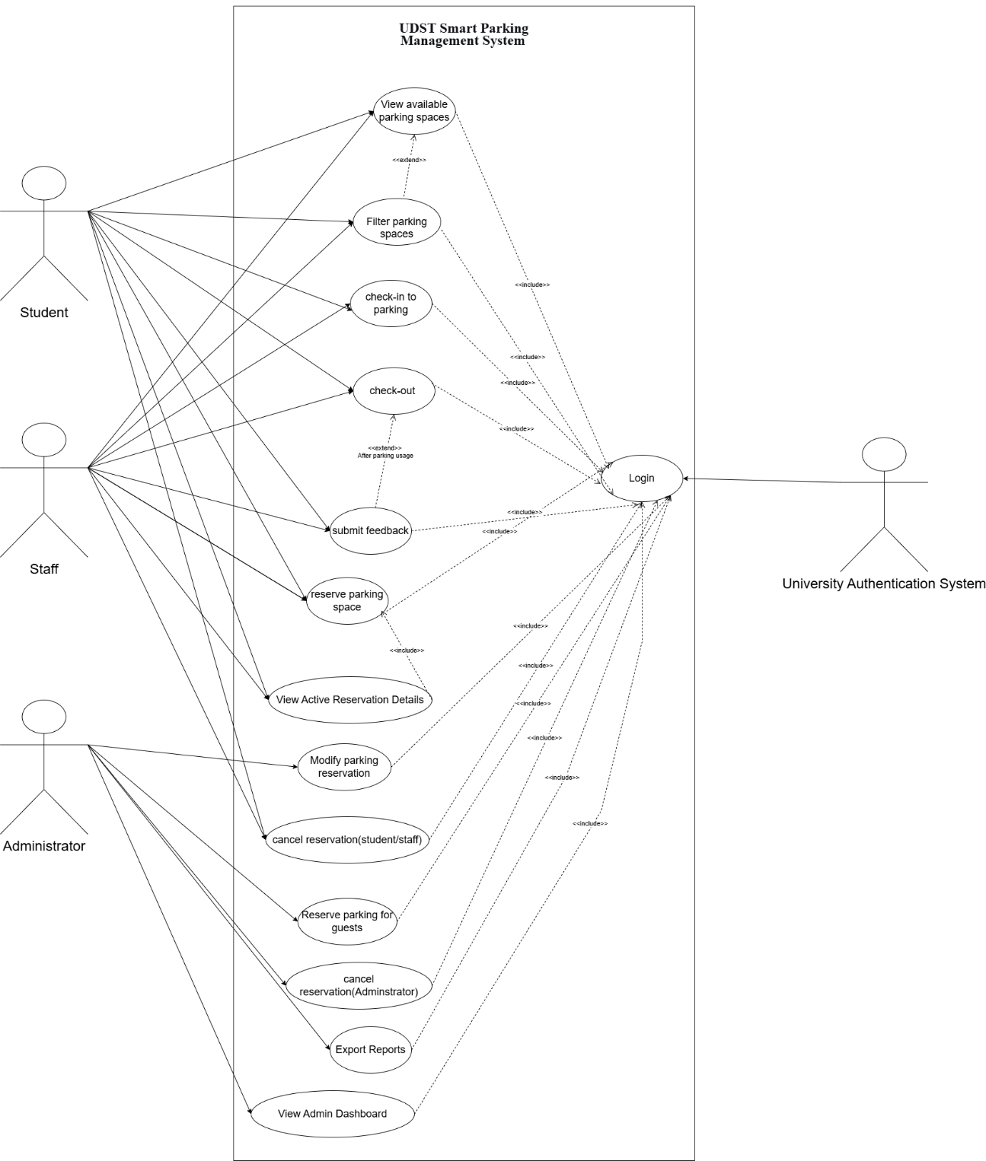

7.3 Requirements-to-Requirements Traceability Matrix

Tracibility_matrics.xlsx

7.4 Validation Matrix

validation_matrix.xlsx

